Supplement: Manufacturing Instructions for CLOS-IT
Materials:
1 18x18cm plastic frame & mold 1 measuring cup
1 pack Powermesh 1 mixing stick
1 tub Dragon Skin 30 1 set Silc Pig dyes
1 tub Ecoflex 00-30 1 tube silicone adhesive (SilBond)
1 tub Soma Foama

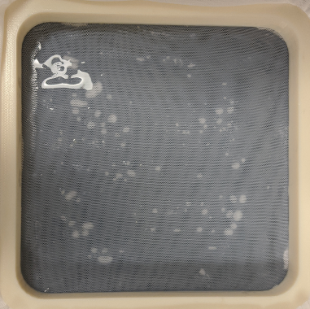
Instructions: *Fascia and skin are more efficiently made two-at-a-time. If doing this, double the quantities listed below.
1 Preparing Fascia
- Secure 3 layers of Powermesh in the 18x18cm plastic frame. Adjust as needed so the fabric lies flat against the benchtop.
- Combine 35cc of each Dragon Skin 30 component (70cc total) and stir thoroughly.
- Pour the mixture onto the layered Powermesh and spread evenly with the mixing stick.
- Let cure for 16h.
Fascia layer prior to curing

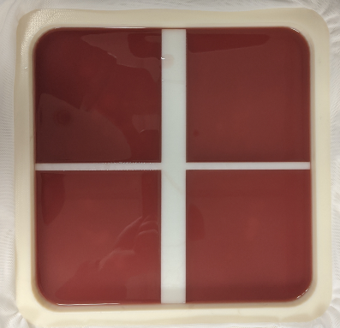
2 Adding Musculature
- Combine 140 cc of each Ecoflex 00-30 component with a small dab of the blood-colored dye and stir.
- Place the mold for the abdominal muscles onto the cured fascia layer, and evenly pour the Ecoflex into the four spaces created by the mold.
- Let cure for 4h.
Muscle layer prior to curing
3 Adding Subcutaneous Fat
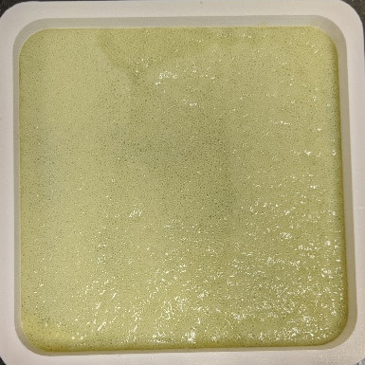
- Remove the plastic frame from the combined fascia and muscle clayers and place the frame flat on the benchtop.
- Combine 70cc of each Soma Foama component with a small dab of yellow dye and stir quickly as the mixture will begin to foam somewhat rapidly.
- Pour the mixture into the plastic frame in three even columns. Because the mixture tends to cure into an uneven surface if poured irregularly or brushed, it is important to pour as evenly as possible.
- After 15min, peel the foam away from the benchtop. Cure time is 2h, but if left for that long, it tends to adhere very tightly to the benchtop. At 15min though, it peels away easily.
Fat layer prior to curing
- Apply an even layer of silicone adhesive to the fascia, on the side opposite the muscle layer, and lay the Soma Foama over it. Press the two layers together so they cure tightly together. Let cure.
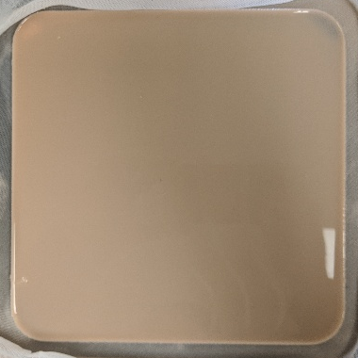
4 Skin
- Secure 1 layer of Powermesh in the 18x18cm plastic frame. Adjust as needed so the fabric lies flat.
- Combine 35cc of each Ecoflex 00-30 component with a small dab of flesh-colored dye and stir well.
- Pour the mixture onto the Powermesh and spread evenly. Let cure for 4h.
- Peel the cured product from the benchtop and affix to the fat layer using the silicone adhesive.
Skin layer post-cure
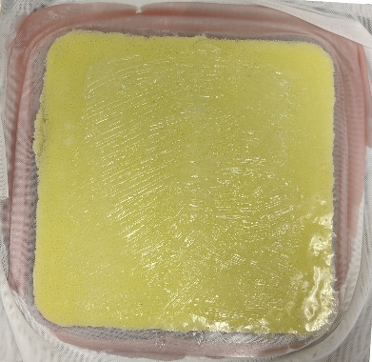
- Once cured, your laparotomy trainer is ready for use.
Fat layer with silicone glue

