Supplementary material – Search Strategies
Ovid
- student-led.tw
- collaborative learning in practice.tw.
- collaborative learning.tw.
- peer learning.tw.
- collaborative coaching.tw.
- placement learning.tw.
- peer assisted learning.tw.
- peer to peer learning.tw.
- peer faculty.tw.
- near-peer.tw.
- 1 or 2 or 3 or 4 or 5 or 6 or 7 or 8 or 9 or 10
- exp Simulation Training/
- high-fidelity simulation training.tw.
- patient simulation.tw.
- simulation learning.tw.
- interactive learning.tw.
- 12 or 13 or 14 or 15 oe 16
- 11 and 16
- limit 18 to (english language and humans)
Scopus
( ( TITLE-ABS-KEY ( "collaborative learning in practice" ) OR TITLE-ABS-KEY ( "collaborative learning" ) OR TITLE-ABS-KEY (“Student-led”) OR TITLE-ABS-KEY (“student-led”) OR TITLE-ABS-KEY ( "peer learning" ) OR TITLE-ABS-KEY ( "collaborative coaching" ) OR TITLE-ABS-KEY ( "placement learning" ) OR TITLE-ABS-KEY ( "peer assisted learning" ) OR TITLE-ABS-KEY ( "peer to peer learning" ) OR TITLE-ABS-KEY ( "peer faculty" ) OR TITLE-ABS-KEY ( "near-peer" ) ) ) AND ( ( TITLE-ABS-KEY ( "high-fidelity simulation training" ) OR TITLE-ABS-KEY ( "patient simulation" ) OR TITLE-ABS-KEY ( "simulation learning" ) OR TITLE-ABS-KEY ( "interactive learning" ) ) ) AND ( LIMIT-TO ( LANGUAGE , "English" ) ) AND ( LIMIT-TO ( EXACTKEYWORD , "Human" ) OR LIMIT-TO ( EXACTKEYWORD , "Humans" ) )

Web of science:
AB=(“student-led”) OR TI (“Student-led”) OR AB=("collaborative learning in practice" ) OR TI=("collaborative learning in practice" ) OR AB=("collaborative learning") OR TI=("collaborative learning") OR AB=("peer learning" ) OR TI=("peer learning" )OR AB=("collaborative coaching" ) OR TI=("collaborative coaching" )OR AB=("placement learning" ) OR TI=("placement learning" ) OR AB=("peer assisted learning" ) OR TI=("peer assisted learning" ) OR AB=("peer to peer learning" ) OR TI=("peer to peer learning" ) OR AB=("peer faculty" ) OR TI=("peer faculty" ) OR AB=("near-peer" ) OR TI=("near-peer" ) https://www.webofscience.com/wos/woscc/summary/cd9a0124-d29e-4a2e-ae47-9acad8caef10-01034b3e72/relevance/1

AB=("high-fidelity simulation training" ) OR TI=("high-fidelity simulation training" ) OR AB=("patient simulation" ) OR TI=("patient simulation" ) OR AB=("simulation learning" ) OR TI=("simulation learning" ) OR AB=("interactive learning" ) OR TI=("interactive learning" )

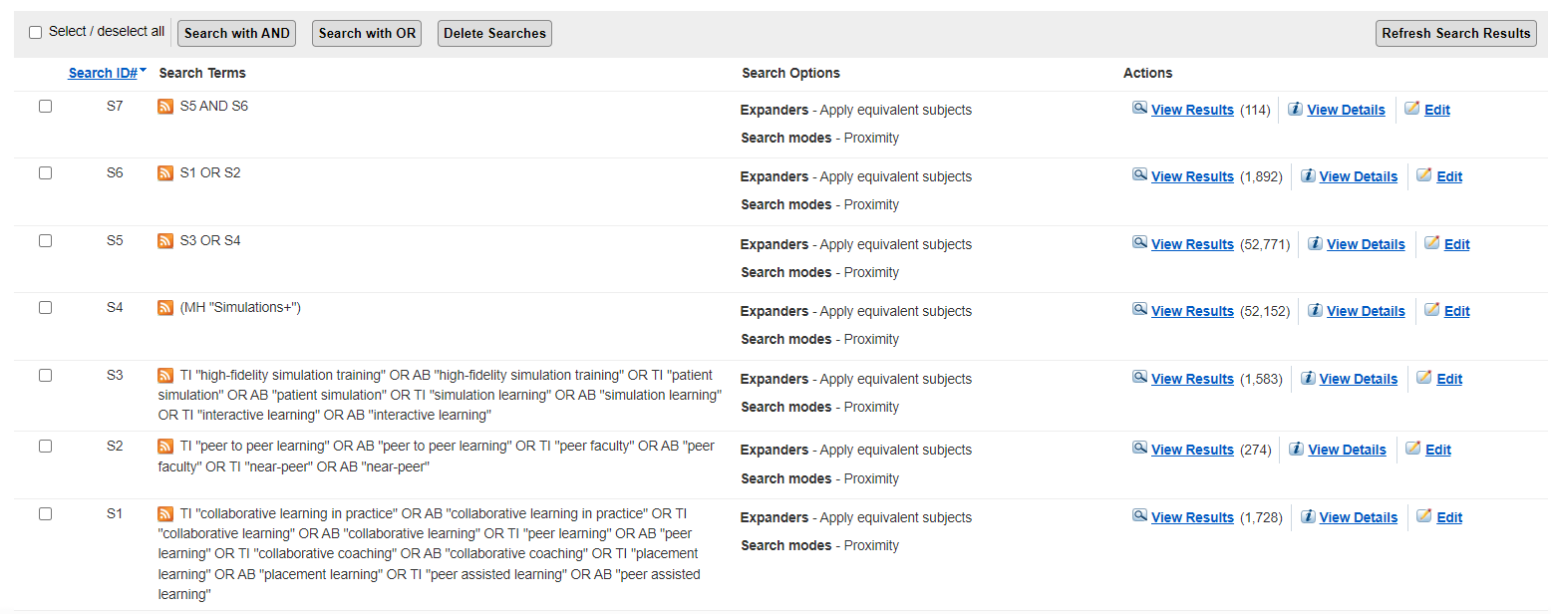
CINAHL/ERIC

